ALOT

RESOURCES

Quick Resources

Podcasts and videos

Supporting Adult Learners in Higer Education

Revisiting Adult Learning Theory-Jeff Cobb

  - Web Pages and Presentations
Harvard Division of Continuing Education
University of Illinois Center for Online Learning, Research and Service
https://www.tc.columbia.edu/organization-and-leadership/adult-learning-and-leadership/resources/essential-references/

Understanding the Adult Learner: An Examination of Current and Future Trends

  - Short articles

“Re-Enrolling Former Students.” The Chronicle of Higher Education, 2023.

Annual Conferences

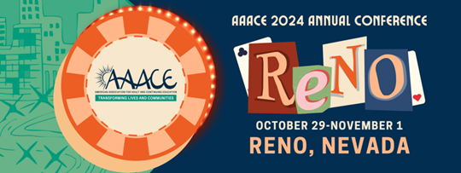
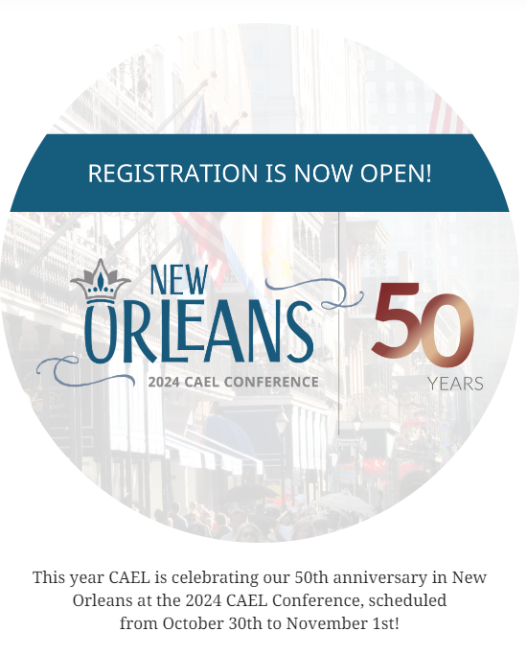

Professional Associations

AAACE American Association for Adult and Continuing Education

The mission of the American Association for Adult and Continuing Education (AAACE) is to provide leadership for the field of adult and continuing education by expanding opportunities for adult growth and development; unifying adult educators; fostering the development and dissemination of theory, research, information, and best practices; promoting identity and standards for the profession; and advocating relevant public policy and social change initiatives.

Vision Statement: The American Association for Adult and Continuing Education (AAACE) is dedicated to the belief that lifelong learning contributes to human fulfillment and positive social change. We envision a more humane world made possible by the diverse practice of our members in helping adults acquire the knowledge, skills and values needed to lead productive and satisfying lives.

CAEL Council for Adult and Experiential Learning
Mission- CAEL engages with educators, employers, and community leaders to align learning and work so that adults achieve continuous, long-term career success.
Vision- Every adult can navigate lifelong learning and career pathways that fuel economic mobility and community prosperity

Articles

Blaschke, Lisa Marie. "Heutagogy and Lifelong Learning: A Review of Heutagogical Practice and Self-Determined Learning." International Review of Research in Open and Distance Learning, vol. 13, no. 1, 2012, pp. 56-71. doi:10.19173/irrodl.v13i1.1076. Link

Boghian, Ioanna, et al. “Illustrations of Best Practices in Building Creativity Skills in Adult Learners.” Journal of Innovation in Psychology, Education and Didactics, vol. 26, no. 1, pp 87-106. Link

Chang, Sang. “Applications of Andragogy in Multi-Disciplined Teaching and Learning.” Journal of Adult Education, vol.39, no.2, 2010, pp. 24-35. Link

Diep, Nguyet A., et al. “Predicting Audl Learners´online participation: Effects of altruism, performance expectancy, and social capital.” Computers and Education, vol. 101, Oct. 2016, pp. 84-101. Link

Fornaciari, C. J., and Lund Dean, K. "The 21st-Century Syllabus: From Pedagogy to Andragogy.” Journal of Management Education, vol. 38, no. 5, 2014, pp. 701-723. doi:10.1177/1052562913504763. link

Harnish, Richard J., et al. "Creating the Foundation for a Warm Classroom Climate." Observer, vol. 24, no. 1, January 2011. link
Lewis, Nicole and Venise Bryan. “Andragogy and teaching techniques to enhance adult
learners’ experience.” Journal of Nursing Education and Practice. July 14, 2021. Link
Merriam, Sharan B. “Andragogy and Self-Directed Learning: Pillars of Adult Learning Theory.” New Directions for Adult and Continuing Education, vol. 89, 2001, pp 3-14. Link

Books

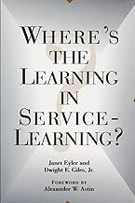 | Eyler, Janet et al. Where's the Learning in Service-Learning?  Jossey Brass, 1999.  This timely volume is the first to explore service-learning as a valid learning activity. The authors present extensive data from two groundbreaking national research projects. Their studies include a large national survey focused on attitudes and perceptions of learning, intensive student interviews before and after the service semester, and additional comprehensive interviews to explore student views of the service-learning process.
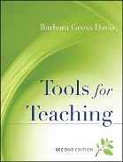 | Gross Davis, Barbara. Tools for Teaching. Jossey Brass, 2009.  A rich compendium of classroom-tested strategies and suggestions designed to improve the teaching practice of beginning, midcareer, and senior faculty members. Forty-nine teaching tools cover both traditional tasks--writing a course syllabus, delivering a lecture--and newer, broader concerns, such as responding to diversity and using technology
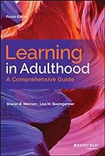 | Merriam, Sharan B., and Lisa Baumgartner. Learning in Adulthood: A Comprehensive Guide. Jossey Bass, 2020.  Now in its fourth edition, this comprehensive volume is fully revised to reflect the latest developments in theory, research, and practice. The authors integrate foundational research and current knowledge to present fresh, original perspectives on teaching and learning in adulthood. Written by internationally-recognized experts, this market-leading guide draws from work in sociology, philosophy, critical social theory, psychology, and education to provide an inclusive overview of adult learning.
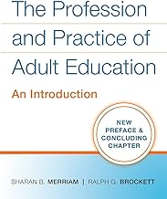 | Sharan B. Merriam and Ralph G. Brockett. The Profession and Practice of Adult Education: An Introduction. Jossey Bass, 2011.  The Profession and Practice of Adult Education is a timely book and an excellent introduction to the field. Drawing from an extensive volume of literature, it provides comprehensive coverage and a clear guide. Graduate students will benefit from it and practitioners will be kept abreast of changes that are occurring.
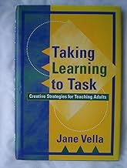 | Vella, Jane. Taking Learning to Task: Creative Strategies for Teaching Adults. Jossey Bass, 2000.  Vella shifts the spotlight from teaching tasks to learning tasks. Unlike traditional teaching methods, learning tasks are open questions leading to open dialogue between teacher and learner. To illustrate this unique approach, Vella provides seven steps to planning learning-centered courses, four types of learning tasks, a checklist of principles and practices, critical questions for instructional design, key components for evaluation, and other tools. She also shares real-world examples of successful learning programs, including online and distance-learning courses.
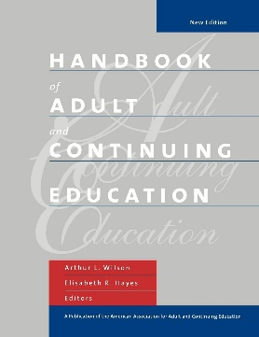 | Wilson, Arthur and Elisabeth R. Hayes ed. Handbook of Adult and Continuing Education. Jossey Bass, 2002.  Sponsored by the American Association of Adult & Continuing Education". This monumental work is a testimony to the science of adult education and the skills of Wilson and Hayes. It is a veritable feast for nourishing our understanding of the current field of adult education. The editors and their well-chosen colleagues consistently question how we know and upon what grounds we act. They invite us to consider not only how we can design effective adult education, but also why we practice in a particular socio-economic context."
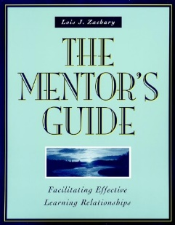 | Zachary, Lois J. The mentor´s Guide. Jossey Bass, 2008.  Thoughtful and rich with advice, The Mentor's Guide explores the critical process of mentoring and presents practical tools for facilitating the experience from beginning to end. Now managers, teachers, and leaders from any career, professional, or educational setting can successfully navigate the learning journey by using the hands-on worksheets and exercises in this unique resource.

Adult education journals

https://www.tc.columbia.edu/organization-and-leadership/adult-learning-and-leadership/resources/major-journals/

