WHAT CAN YOU DO WITH A GRADUATE DEGREE IN PSYCHOLOGY?...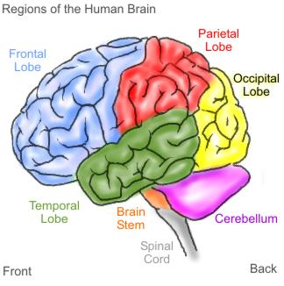

Preparation For Graduate School

If you are considering graduate school you should speak to a professor about how you can increase your odds of being accepted into a program. Here are some guidelines regarding what to aim for:

- GPA of 3.5 or higher
- High GRE verbal+quantitative score (approximately 160 or above)
- At least 1-3 years of research experience
- Conference presentation and/or research publication
- Senior honors thesis
- Internship
- You will need letters of recommendation from faculty so you need to get to know a faculty member

Most graduate programs in psychology will require you to submit GRE general test scores as part of your application. You should give yourself time to prepare for this test. Some programs additionally require applicants to take the psychology subject test. Unlike the general test, this test is only given 3 times a year---this means you will have plan ahead to make sure you will get your scores back in time to meet application deadlines.
Careers with a Graduate Degree
Art Therapist
Behavioral Pharmacologist
Chemical Senses Specialist
Child Psychologist
Clinical Psychologist
Counseling Psychologist
Family Counselor
Federal Drug Science Specialist
Forensic Psychologist
Human Factors Engineer
Human-Computer Interface Designer
Industrial Organizational Psychologist
Market Research Consultant
NASA Research Psychologist
Police Psychology in the Federal Government
Professor
Research Director for a Non-Profit Organization
Research Psychologist
School Psychologist
Science Museum Education and Research Specialist
Science Writer
Scientist at a Federal Research and Development Center
Social Worker
Statistician
Trial Consultant
For more information and some descriptions of what items on the list mean go to
http://www.stats.bls.gov/oco/
http://online.onetcenter.org/
http://www.apa.org/careers/index.aspx
http://www.apa.org/science/resources/careers/index.aspx

Psychology Department
2061 Science Hall
Office hours:
Fall and Spring 8:30-4:30
Summer 8:00-5:15
(973) 720-2148

